GROUP-4

Appium+Selenium

**Code**

package sampletest;

import java.net.MalformedURLException;

import java.net.URL;

import java.time.Duration;

import java.util.concurrent.TimeUnit;

import org.aspectj.lang.annotation.After;

import org.openqa.selenium.By;

import org.openqa.selenium.Dimension;

import org.openqa.selenium.WebElement;

import org.openqa.selenium.remote.CapabilityType;

import org.openqa.selenium.remote.DesiredCapabilities;

import org.testng.Assert;

import org.testng.annotations.AfterTest;

import org.testng.annotations.Test;

import io.appium.java_client.TouchAction;

import io.appium.java_client.android.AndroidDriver;

import io.appium.java_client.touch.WaitOptions;

import io.appium.java_client.touch.offset.PointOption;

public class NewTest {

private static AndroidDriver<WebElement> driver;

public static void scroll(AndroidDriver<WebElement> driver)

{

TouchAction action =new TouchAction(driver);

Dimension size =driver.manage().window().getSize();

int start_x=(int) (size.width*.5);

int start_y=(int) (size.height*.5);

int end_x=(int) (size.width*.5);

int end_y=(int) (size.height*.3);

action.press(PointOption.point(start_x, start_y))

.waitAction(WaitOptions.waitOptions(Duration.ofSeconds(1)))

.moveTo(PointOption.point(end_x, end_y)).release().perform();

}

@Test

public void testone() throws MalformedURLException, InterruptedException

{

DesiredCapabilities capabilities = new DesiredCapabilities();

capabilities.setCapability(CapabilityType.BROWSER_NAME, "");

capabilities.setCapability("deviceName", "Pixel 4 XL API 30");

capabilities.setCapability("appPackage", "io.selendroid.testapp");

capabilities.setCapability("appActivity", "io.selendroid.testapp.HomeScreenActivity");

capabilities.setCapability("autoGrantPermissions",true);

driver = new AndroidDriver<WebElement>(new URL("http://127.0.0.1:4723/wd/hub"), capabilities);

driver.manage().timeouts().implicitlyWait(5, TimeUnit.SECONDS);

driver.findElement(By.id(

"com.android.permissioncontroller:id/continue_button")).click();

driver.findElement(By.id("android:id/button1")).click();

String s =

driver.findElement(By.id("io.selendroid.testapp:id/visibleButtonTest")).

getText(); Assert.assertEquals(s, "Display text view");

String s1 =

driver.findElement(By.id("io.selendroid.testapp:id/showPopupWindowButton")).

getText(); Assert.assertEquals(s1, "Display Popup Window");

driver.findElement(By.xpath("//android.widget.EditText[@content-desc='my_text_fieldCD']")).sendKeys("Mukesh Selenium Appium");

driver.findElement(By.id("io.selendroid.testapp:id/startUserRegistration")).click();

Thread.sleep(2000);

driver.findElement(By.id("io.selendroid.testapp:id/inputUsername")).sendKeys("Admin");

driver.findElement(By.id("io.selendroid.testapp:id/inputEmail")).sendKeys("abc@gmail.com");

driver.findElement(By.id("io.selendroid.testapp:id/inputPassword")).sendKeys("Admin");

driver.findElement(By.id("io.selendroid.testapp:id/inputName")).clear();

driver.findElement(By.id("io.selendroid.testapp:id/inputName")).sendKeys("Mr John");

driver.findElement(By.id("android:id/text1")).click();

driver.findElement(By.xpath("/hierarchy/android.widget.FrameLayout/android.widget.FrameLayout/android.widget.FrameLayout/android.widget.LinearLayout/android.widget.LinearLayout[2]/android.widget.ListView/android.widget.CheckedTextView[6]")).click();

scroll(driver);

driver.findElement(By.id("io.selendroid.testapp:id/input_adds")).click();

driver.findElement(By.id("io.selendroid.testapp:id/btnRegisterUser")).click();

Thread.sleep(2000);

driver.findElement(By.id("io.selendroid.testapp:id/buttonRegisterUser")).click();

Thread.sleep(2000);

}

}

**Output**

[RemoteTestNG] detected TestNG version 7.4.0

Dec 13, 2021 3:12:18 PM io.appium.java_client.remote.AppiumCommandExecutor$1 lambda$0

INFO: Detected dialect: W3C

PASSED: testone

===============================================

Default test

Tests run: 1, Failures: 0, Skips: 0

===============================================

===============================================

Default suite

Total tests run: 1, Passes: 1, Failures: 0, Skips: 0

===============================================

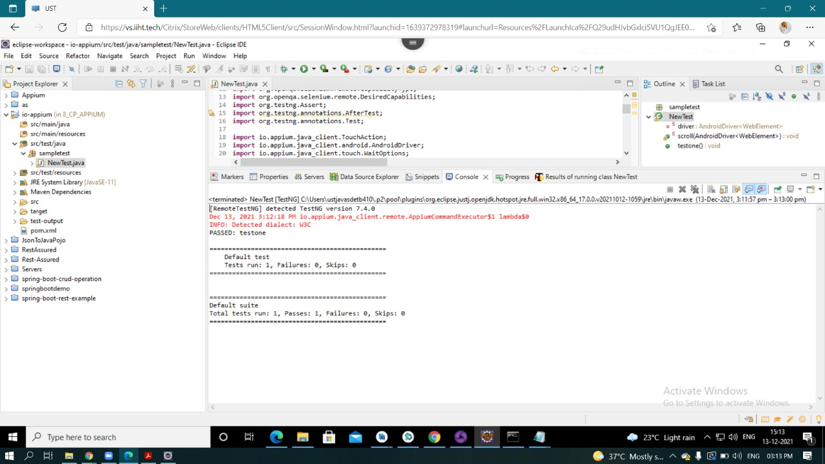

**Steps**

